### LAB EXAM

# FLAG 1 Screenshot 2025-07-01 220040flag 1

# FLAG 2

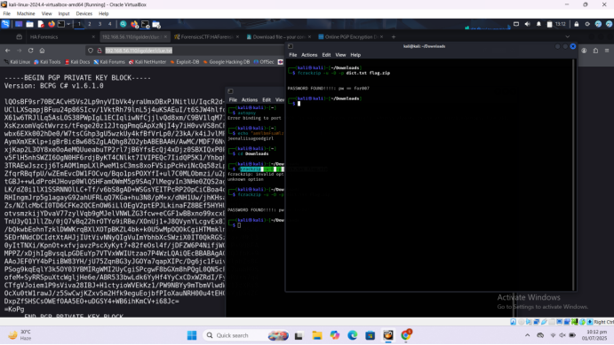

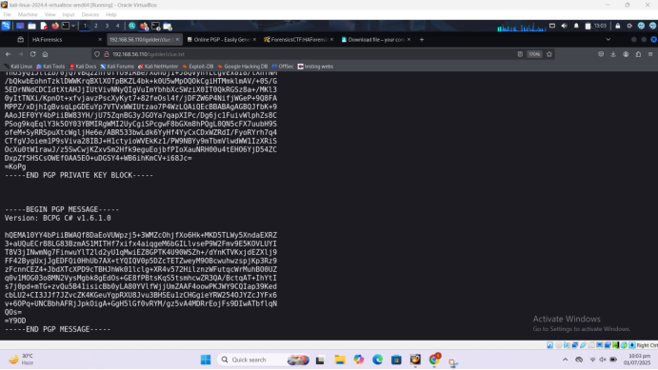

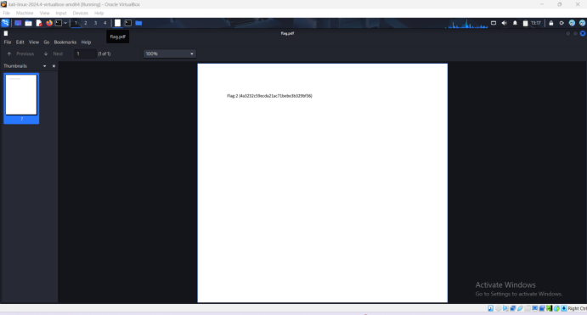

# FLAG 3

# flag3

# FLAG 4

# WhatsApp Image 2025-07-01 at 10.28.44 PM